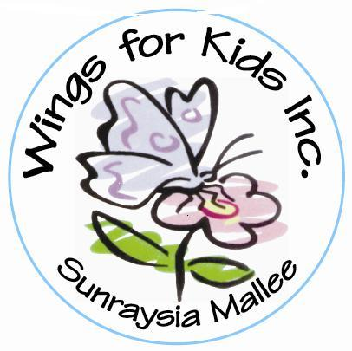
WINGS FOR KIDS INC. SUNRAYSIA MALLEE
ABN number: 45 303 786 180
Inc. Number: A0036324N

PO Box 3484
Mildura Vic 3502

APPLICATION FOR ASSISTANCE FOR THE PROVISION OF AIDS & EQUIPMENT

Surname………………………………………...Given Names……………………………………………

Address………………………………………………………………………………………………………

Date of Birth…………………………Telephone No……………………………………………………....

Parent / Guardian………………………………………………………………………………………...…

Pre School / School Attended (if any) ……………………………………………………………………..

Diagnosis……………………………………………………………………………………...……………..

Aids &/or Equipment required………………………………………………………………………..…...

Has N.D.I.S assistance been sought? Yes/No When……………...……………………………..

Have you applied for assistance from any other organization? Yes/No

If yes, what was the outcome of these applications? …………………………...………………..……….

…………………………………………………………………………………………………………….....

Signature of Parent / Guardian …………………………………………………………………………...

Signature of Diabetic Educator, Case Manager, Allied Health Professional:

………………………………………………………………………..Date………………………………...

DOCUMENTATION REQUIRED:

(1) Supporting letter providing information about the child/teenager, explaining about the applicant and
their need for assistance from the referring Allied Health Professional/Case Worker/Diabetic Educator.
(2) Two quotes for cost of requested item.
(3) Completed application form.

PERMISSION REQUEST: (for the Person completing this application.)

If your application is successful, Wings for Kids Inc would like permission to photograph the recipient receiving the donated equipment. Photographs would then be used on Wings for Kids Inc webpage and social media formats.

I/We give permission for Recipient: ….…………………………………... to have their photo taken.
(Name - please print)

Signed: Parent/Guardian: ………………………………………Signed…………………………................
(Name - please print)

I/We do not give permission for photographs to be taken: Signed: Parent Guardian……………………….

Please forward this application along with all supporting documentation to PO Box 3484, Mildura, 3502. Our meetings are usually held on the 2nd Monday of every month and for the application to be taken to our monthly meeting, it needs to reach us by the first Monday of the month.

